**CMPT 354 Lab 1**

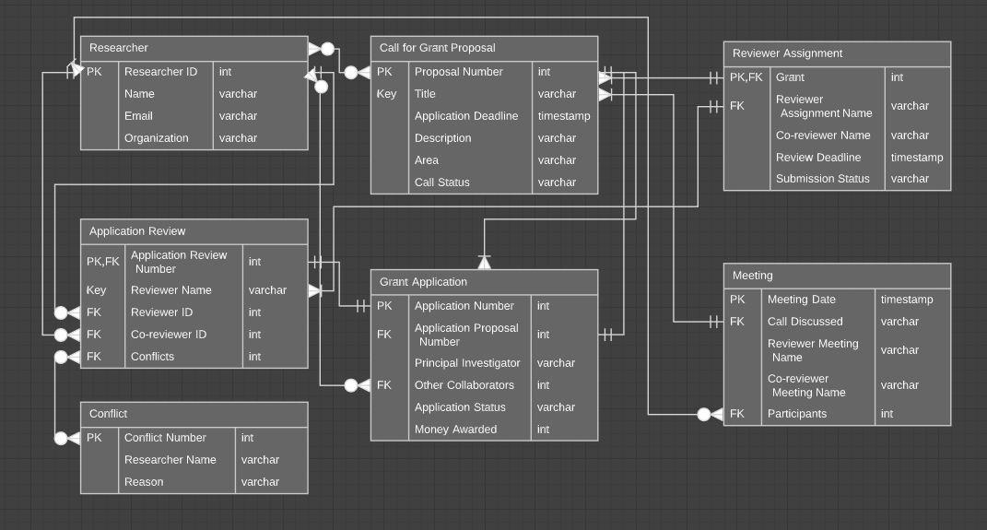Rajan Grewal 301335629

1. Researcher table with PK Researcher ID.

Call for Grant Proposal table with PK Proposal Number and a key on Title since it is referenced in another FK.

Grant Application table with PK application number, FK Application Proposal Number referencing Proposal Number from Call for Grant Proposal, and FK Other Collaborators Referencing Researcher ID from Researcher. The Proposal Number foreign key is to determine which call the application is for.

Application Review table with FK Application Review Number referencing Application Number from Grant Application table, FK Reviewer ID and Co-reviewer both referencing Researcher ID, FK Conflict referencing Conflict Number, and a key on Reviewer Name since it is referenced in another FK.

Conflict Table is needed because an application review could have multiple conflicts. It includes PK Conflict Number.

Reviewer Assignment with FK and PK Grant referencing Proposal Number and FK Reviewer Assignment Name referencing Reviewer Name from Application Review.

Meeting table with PK Meeting Date, FK Call Discussed referencing Title, and FK Participants referencing Researcher ID from Researcher.

KEEP IN MIND PARTICIPANTS, OTHER COLLABORATORS, AND CONFLICTS ARE STORED BY IDs. THE VALUE DOES NOT REPRESENT THE NUMBER OF PARTICIPANTS, COLLABORATORS, OR CONFLICTS.

1. No extra assumption.
2. Money awarded must be a nonnegative number. There cannot be two meetings at the same time. If the review is not submitted by the deadline, the submission status should be changed to “Overdue”. Since the Title attribute is a key, if a duplicate title is added, it should have a number after it such that the title-number combination is unique, and same goes for the Reviewer Name attribute. The Co-reviewer shouldn’t be reviewing his or her own grant.